Adirondack Park Invasive Plant Program (APIPP)
2022 Year-End Partner Meeting Notes
December 1, 2022 | 9:30am-12:00pm | Zoom

Present for APIPP
- Becca Bernacki, Terrestrial Invasive Species Coordinator
- Brian Greene, Aquatic Invasive Species Coordinator
- Shaun Kittle, Communications Coordinator
- Tammara Van Ryn, Program Director
- Zack Simek, Conservation and GIS Analyst

Speaker
- Bill Brosseau, Paul Smith’s College Adirondack Watershed Institute (AWI)

Attendees

- Aaron Ziemann, NYS Adirondack Park Agency
- Alex Novick, Lake George Land Conservancy (LGLC)
- Alexandra von Bieberstein, NYS Department of Transportation (NYSDOT)
- Bill Widrig, Volunteer
- Blake Neumann, Adirondack Council
- Bob Bombard, Warren County SWCD
- Bob Slocum, NYS Department of Environmental Conservation
- Brea Arvidson, Lake George Association
- Christine Colley, NYSDOT
- Derek Rosney, NYSDOT
- Dirk Bryant, The Nature Conservancy
- Emily Tyner, Lake Clear Association
- Erin Vennie-Vollrath, NYSDEC/ NEIWPCC
- Ezra Schwartzberg, Adirondack Research
- Guy Middleton, Upper Saranac Foundation
- James Pinheiro, Adirondack Park Agency
- Jessica Grant, Adirondack Council
- Jim Townsend, Adirondack Landowners Association
- John Blaser, Volunteer
- Kenneth Hawks, RLPF
- Liz Metzger, Ausable River Association
- Lorraine Mott, Canada Lake Conservation Association
- Meg Wilkinson, NY Natural Heritage Program
- Michael Horn, LGLC
- Michele Curry, Blue Mountain Lake Water Watch
- Neil Chippendale, Schroon Lake Association, Schroon Lake Park District
- Peg Olsen, The Nature Conservancy
- Richard Chen, Barn Owl Technologies
- Sarah Sossei, NYSDOT
- Steve Case, NYSDEC
- Susan Smith, Volunteer
- Thom Allgaier, NYS Department of Ag and Markets
- Thomas Firkins, Essex County SWCD
- Tom Collins, AWI
- Walt Lender, Lake George

There were over 40 individuals logged on to the Zoom call. Participants who called in or who were not identified on the Zoom log may not be included in the list above.

Meeting Notes
For a complete record of the meeting, please refer to the recording that is posted on APIPP’s website: www.adkinvasives.com or view on YouTube.
Welcome and Introductions
- Tammara Van Ryn welcomed participants with a reading from The Singing Wilderness by Sigurd Olsen. She then reviewed the agenda for the meeting.
- Tammara provided context for the meeting, noting the importance of the Adirondack region for species migration and climate resilience and the potential impact of warming winters on the suitability of habitat for invasive species.

APIPP Summer Field Results Program
- Becca Bernacki provided an overview of APIPP’s terrestrial invasive species field season results. She shared highlights of the work performed by the terrestrial early detection and rapid response (EDRR) team, invasive species management stewards, forest pest research assistant, program staff and others.
- Becca highlighted the high percentage (greater than 60%) of treated sites that no longer have invasive species present.
- She also noted that APIPP stewards have helped eliminate garlic mustard from seven NYSDEC campgrounds.
- The new forest pest research assistant monitored more than 60 sites and 17 traps for five different forest pests.
- Forest pest hunters entered over 500 observations related to hemlock woolly adelgid (HWA) and beech leaf disease into iMapInvasives.
- Becca highlighted two species of interest that are new to Adirondack PRISM: beech leaf disease and wineberry.
- Zack Simek provided an update on the HWA work in the Lake George region and several innovation and research projects.
- With Zack’s leadership, over 1,400 trees have been treated on Dome Island. Zack also reported on the NYS Hemlock Initiative release of biocontrol beetles at a Lake George area site.
- He reported on preliminary data about the impacts of deer herbivory on native tree and invasive species regeneration.
- He also shared preliminary data about a new project to evaluate the effectiveness of alternatives to glyphosate for the control of knotweed.
- Brian Greene provided an overview of APIPP’s aquatic invasive species (AIS) monitoring program, which includes efforts by partners, an early detection team, lake protector volunteers, and lake management tracker participants.
- This was the 21st season of APIPP’s volunteer lake monitoring program; a record number of 108 surveys were submitted by volunteers.
- APIPP’s early detection team, contracted through Adirondack Research, surveyed lakes in the southwestern Adirondacks. The team monitored 42 lakes.
- No new AIS were found in the Adirondacks, but five already-invaded waterbodies had additional AIS detected in 2022.
- This was the fifth year of the lake management tracker program, which is used on lakes known to be invaded by AIS where management is or will occur. Five lakes participated.
- APIPP also worked with SLELO on an eDNA monitoring project, and monitored 66 locations for AIS.

Adirondack Watershed Institute (AWI) Summer Field Results
- Bill Brosseau provided an overview of AWI’s watercraft inspection steward program including the program’s history and preliminary 2022 data.
- The most common species stewards have intercepted over the last five years are Eurasian watermilfoil, curly-leaf pondweed, and zebra mussels.
- In 2022, approximately 70,054 boats were inspected, 733 of which had AIS (1.1%). This is significantly lower than last year’s 2.6% AIS detection rate.
- There were 2,815 decontaminations performed. This is a lower number of decontaminations than last year, but about the same percent of boats decontaminated (4%).
- Staff challenges limited the number of sites with stewards and the number of hours with stewards present which may be responsible for some of the lower numbers in 2022.

Community Engagement
- Shaun Kittle provided a summary of APIPP’s education and communications highlights and upcoming events.
- APIPP received expanded media coverage this year in television, print and online media.
- A very informative and successful Adirondack Invasive Species Summit was held in October.
- A full suite of educational programs was offered throughout the year. The winter series will begin with an HWA training for Forest Pest Hunters on January 24, 2023,
- APIPP has just released a new Field Guide to Terrestrial Invasive Species of the Adirondacks.

Break
Partners were asked to submit slides with program highlights related to invasive species for 2022; the Adirondack Park Agency and the NYS Department of Transportation provided slides. The slides were displayed on the screen during the break.

Adirondack PRISM Strategic Plan
- Tammara provided an overview of the new Adirondack PRISM 2023-2027 Strategic Plan. She noted the plan was designed so that all partners could embrace a new vision and mission statement and find ways to contribute to the four goals.

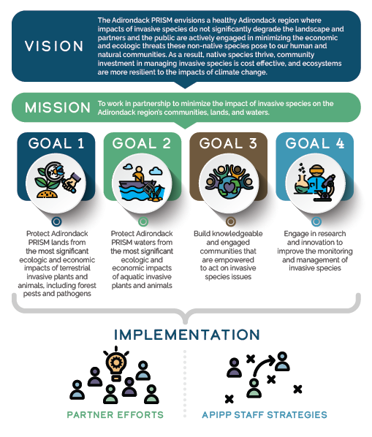

Partner Data Dashboard
- Tammara Van Ryn provided a quick overview of data dashboards.
- Zack Simek then solicited feedback on a proposed Adirondack PRISM dashboard.
- Participants were asked to respond to a series of poll questions shown on the Zoom screen.
- How likely is it that your organization would annually contribute data to an Adirondack dashboard? (Likely 11/19; Unlikely 3/19; Unsure 5/19)

- Would it limit your organization's participation if only one person/computer per organization could complete the form each year? (No 11/15; Yes 1/15; Unsure 3/15)

- To determine whether the timing of the data request matters, indicate which months would be best for you to respond to an annual request for data. (11 of 14 with a preference suggested January/February would be the best time)
- How valuable do you think an Adirondack dashboard would be to you/your organization? (Very 9/20; Somewhat 9/20; Unsure 2/20; Not at All 0/20)
- Would you be willing to contribute your organization's 2022 data in January or February of 2023 to test the data-collection form? (Yes 7/15; No 5/15; Maybe 3/15)
- A draft data dashboard will be piloted in the spring of 2023.

The meeting adjourned at 11:55am.

